Geophysical survey at Butchers and Glebe Fields, Aberlady
(East Lothian): a preliminary report

Alice Blackwell BA MPhil
Department of Archaeology
University of Glasgow

Undertaken for the Aberlady Heritage Project in conjunction with CFA

CONTENTS

- Summary 4

- Introduction 6

2.1 General introduction 6
2.2 Situation, topography and geology 6
2.3 Archaeological background 6
2.4 Previous geophysical survey 7

- Aims & methodology 8

3.1 Survey aims 8
3.2 Survey methodology 8
3.3 Gradiometer methodology 9
3.4 Resistivity methodology 9

- Survey results 9

4.1 Butchers Field
4.1.1 Resistivity results and interpretation 9
4.1.2 Gradiometry results and interpretation 12
4.2 Glebe Field
4.2.1 Survey area I: resistivity results 14 4.2.2 Survey area I: gradiometer results 16
4.2.3 Survey area I: interpretation 18
4.2.4 Survey area II: resistivity results 21

4.5 Craigielaw Golf Course
4.5.1 Resistivity results 21
- Conclusions 22

- Bibliography 24

FIGURES

Figure 1 Location map and survey area
Figure 2 Butchers Field, unprocessed resistance data, 0.5m probe separation
Figure 3 Butchers Field, unprocessed resistance data, 1m probe separation
Figure 4 Butchers Field, processed resistance data, 0.5m probe separation, a) greyscale, b) trace
Figure 5 Butchers Field, processed resistance data, 1m probe separation, a) greyscale, b) trace
Figure 6 Butchers Field, interpretative diagram of resistance results
Figure 7 Butchers Field, unprocessed gradiometer data
Figure 8 Butchers Field, processed gradiometer data
Figure 9 Butchers Field, interpretative diagram of gradiometer results
Figure 10 Glebe Field area I, unprocessed resistance data, 0.5m probe separation
Figure 11 Glebe Field area I, unprocessed resistance data, 1m probe separation
Figure 12 Glebe Field area I, processed resistance data, 0.5m probe separation, a) greyscale, b) trace
Figure 13 Glebe Field area I, processed resistance data, 1m probe separation, a) greyscale, b) trace
Figure 14 Glebe Field area I, interpretative diagram of resistance results
Figure 15 Glebe Field area I, unprocessed gradiometer results
Figure 16 Glebe Field area I, processed gradiometer results, a) greyscale, b) trace
Figure 17 Glebe Field area I, interpretative diagram of gradiometer results
Figure 18 Glebe Field area II, unprocessed resistance data, 1m probe separation
Figure 19 Glebe Field area II, processed resistance data, 1m probe separation,
Figure 20 Craigielaw Golf Course, unprocessed resistance data, 0.5m probe separation (top), 1m probe separation (bottom)
Figure 21 Craigielaw Golf Course, processed resistance data, 0.5m probe separation (top), 1m probe separation (bottom), a) greyscale, b) trace
Figure 22 Craigielaw Golf Course, interpretative diagram of resistance results
1.0 SUMMARY

As part of the Aberlady Heritage Project, a community-led initiative in conjunction with CFA and supported by the Heritage Lottery Fund, gradiometer and resistivity survey were undertaken in the neighbouring Butchers Field and Glebe Field, Aberlady (East Lothian) in April 2008. A narrow strip immediately to the west of Glebe Field, and now within Craigielaw Golf Course, was also surveyed. The two-week survey was undertaken by local volunteers and supervised by Alice Blackwell (University of Glasgow). Glebe Field is scheduled and SMC was granted in advance of the survey.

Glebe Field contains the remains of the 16th century Kilspindie Castle. Previous geophysical surveys (Neighbour et al. 1995; Neighbour et al. 1998) undertaken within Glebe Field identified numerous features, including some suggested as possible Anglo-Saxon period structures. No archaeological investigation had previously been undertaken in the neighbouring Butchers Field, immediately to the east of the scheduled area, or in the golf course to the west. In recent years metal detecting in Glebe Field has yielded a considerable artefact assemblage, including a number of late 8th–9th century Anglo-Saxon objects and 9th century coins, and an Anglian sculptured cross fragment was found in the 19th century immediately to the south of Glebe Field.

The aims of the survey were to test whether archaeological remains continue beyond the scheduled area of Glebe Field, and to refine earlier geophysical results within the scheduled area. To this end, the majority of Butchers Field was surveyed, together with the narrow strip in the golf course, whereas in Glebe Field survey was targeted guided by previous results.

In Butchers Field a number of archaeological features were noted, in addition to a large geological channel. These included just over half the circumference of a large low resistance ring-shaped anomaly which appears to relate to a large ditched enclosure, of possible prehistoric date. Results from the interior of this feature were ill-defined and no associated features could be identified. An unusual low-resistance feature, superficially hall-shaped, to the west of the ring-enclosure seems likely to be natural. A subtle area of low-resistance with linear edges and a higher resistance centre was identified between these features but remains difficult to interpret.

Both resistance and magnetic survey identified a long linear anomaly running east to west near the northern extent of the field, and turning right-angles towards the south at each end. This feature is on a similar alignment to the field wall which divides the Butchers and Glebe fields, and relates to an old field system, most likely the remains of a wall or bank. Striping evident within the resistance results relates to ploughing within this field system. Large low-resistance features to the north might be associated ditches, although similar anomalies in Glebe Field were interpreted in 1998 as natural. Other features include possible field drains evident as three linear low-resistance anomalies in the southern part of the field, aligned differently to the field bank/wall. In the south-west corner of the field, low-resistance anomalies may form part of an irregularly shaped enclosure, but display similar responses to other anomalies identified in the field as natural. Butchers Field was affected by substantial magnetic disturbance, probably relating to modern bonfires, which inhibited the ability to identify archaeological features.

Results from area of the possible Anglo-Saxon halls in the south of Glebe Field identified two groups of anomalies, together with other features. One set of anomalies identified in both the resistance and gradiometer results resemble a trench-built timber hall with additional annexe, the latter feature characteristic of Anglo-Saxon settlements. However, doubt was expressed about this interpretation given the massive size of the anomaly, which would make the Aberlady feature uniquely large, and because key intersections of anomalies are confused by crossing features, likely to be later drains. It is possible that the anomalies represent a large trench-defined and perhaps fenced enclosure, as found associated with some Anglo-Saxon structures. Alternatively, the given the ambiguous nature of the anomalies forming the ‘annexe’, ascription to the Anglo-Saxon period may be mis-guided.

Also in Glebe Field, a second possible timber hall with rounded rather than sharp corners and significantly different proportions was suggested to lie immediately to the north. Parallels for the proportions, shape and possible internal features were drawn with Neolithic timber halls such as that recently excavated at Lockerbie. A low-resistance feature likely to be the remains of a ditch may be associated with this structure, and appeared at least to partly enclose it.

A defined area of uniform resistance, in which no anomalies were detected seems anomalous with the results from the rest of the survey areas. This seems perhaps to relate to landscaping activity associated with the Manse and its gardens, immediately to the south. The Gradiometer was able to identify anomalies within this area, including a further section of a probable pipe, identified elsewhere in the survey area with the resistance meter.

A second area in Glebe Field was surveyed with resistance meter only, in order to target a feature identified in the 1998 survey. User error rendered the results from this area of little value, and it did not add to the previous results. However, previous interpretation of the feature as a ditched enclosure with parallels at the Anglo-Saxon site at Sprouston (Scottish Borders) was questioned, and similar features are very difficult to parallel at known Anglo-Saxon sites. The prospective survey of a 20m strip of the Kilspindie Golf Course identified a number of features which seem likely to relate to drainage and landscaping. No clearly archaeological features were identified and there were no indications of surviving features from Glebe Field extending into the area.
2.0 INTRODUCTION

2.1 General

Between 5th–20th April 2008 resistance and gradiometer surveys were undertaken in Glebe Field, Butchers Field and Craigielaw Golf Course, Aberlady (East Lothian) (Figure 1). The surveys formed one element of a multi-strand community-led initiative called the Aberlady Heritage Project (for more details see project design document at: http://www.elh.info/site/pages/local-heritage-groups/aberlady-conservation-society/aberlady-heritage-project.php). CFA oversaw the archaeological work for the project generally, and Alice Blackwell (University of Glasgow) supervised the geophysical survey. The project is supported by the Heritage Lottery Fund.

The survey areas are on the coast to the north of Aberlady village, and comprise two neighbouring arable fields and a narrow strip of Craigielaw Golf Course. Glebe Field, owned by the Church of Scotland, is scheduled and contains the remains of the 16th century Kilspindie Castle (NT 4617 8004; NMRS no. NT48SE 3). Permission was obtained from all the land owners, and SMC granted for work within Glebe Field.

2.2 Situation, topography and geology

Glebe and Butchers Fields are both fairly flat, covered with tussock grass and are currently affected by moles. A stone wall and hedge separate the fields. In the northern half this boundary is raised, presumably from accumulated wind-blown sand. Houses and gardens border Butchers Field to the south and east. Butchers Field is not square, with the north and west walls on different alignments and visibly of different construction.

Glebe Field is bordered to the south by houses, including the Manse, and the parish church. The church sits above the field on a rise which continues into the south-west corner of the field and stops fairly abruptly, perhaps suggestive of landscaping activity in the past (supported by the geophysical results, see below). The rectangular remains of Kilspindie castle survive as low walls, less than 1m in height, and are currently overgrown.

A stone wall and path known as the ‘coffin lane’ separate Glebe Field and Craigielaw Golf Course. The surveyed area of the golf course comprised part of the ‘rough’ with long grass and young trees, and continued towards a landscaped green. The whole survey area is coastal, only a few metres above sea level, and separated from the shore by a single track road. The drift geology is sand with a high density of sea-shell fragments.

2.3 Archaeological background

An 8th century Anglian sculpture cross fragment was discovered in the Manse garden wall in 1863, just to the south of Glebe Field (c. NT 4614 7988). It is very similar to the Abercorn cross and the two have been regarded as products of the same workshop. Traditionally the remains of a chapel dedicated to St Mary are located in the NW corner of the old extent of the churchyard (NT 4614 7988), adjacent to Glebe Field. Several stone coffins were apparently found around 1927 during extension to the cemetery approximately 30 yards from the chapel site. One coffin was noted to be oriented E-W, made of solid stone, without a cover, and chiseled to the shape of a body and the head (see NMRS no. NT47NE 1).

A large assemblage of metal finds from Glebe Field was recovered using systematic metal detecting by Roger MacWee, prior to its scheduling. A significant number of 9th century Anglo-Saxon coins, and several important late 8th-9th century Anglian pieces of metalwork are among the Glebe assemblage. These include a rare and very high quality Mercian-style disc-headed pin head featuring an openwork interlaced animal (TT 445, NMS X.IG 7; Blackwell in prep.). A Roman brooch is also known from the site. No finds were apparently recovered from Butchers Field.

A watching brief was undertaken by AOC in Glebe Field during laying of pipe for field drain in 2000 (Knowles Jackson 2000). The drain ran from Peffer, High Street, north-east through the Glebe Field. Several archaeological features of interest but regarded as of little significance were identified. These included a mortared wall, a cobbled surface, disarticulated animal bones, and a semi-circular arrangement of stones which appeared to be only one stone deep.

On the first day of the present geophysical survey a piece of pottery was found by one of the volunteers in a mole hill in Butchers Field. This has been provisionally identified as a Scottish White Gritty Ware rim sherd from an unusual type of vessel, possibly a jug, with a separately applied handle (pers. comm. R. Will, GUARD).

2.4 Previous geophysical survey

Magnetometer (Neighbour et al. 1995) and resistivity (Neighbour et al. 1998) survey have previously been carried out in Glebe Field. A range of features were identified by the magnetometer survey, and included possible structures associated with Kilspindie Castle. In addition a significant number of probable pits, both in groups and isolated features, and several anomalies suggested to be the remains of enclosures and structures were also identified (Neighbour et al. 1995, 7–8). The responses were relatively subtle and intermittent, and limited interpretation was possible. Nonetheless, at least two phases of use were suggested, one potentially Early Historic on the basis of the finds assemblage from the site (Neighbour et al. 1995, 10).

Resistivity results obtained in 1998 were stronger and permitted more interpretation. Further features associated with Kilspindie Castle were identified (Neighbour et al. 1998, 8, Fig. 2, A, D, C). Several large linear low-resistance anomalies in proximity to the Manse boundary wall were suggested to be the remains of two timber halls, one lying at right angles to the other, which might be Anglian or earlier in date (Neighbour et al. 1998, 8, Fig. 2, E). These features were estimated to be approximately 40m by 20m.

In the west of Glebe Field a series of low-resistance features were interpreted as ditch-defined enclosures which formed a rough crescent shape, divided into three portions (Neighbour et al. 1998, fig. 2, G). This feature was compared with outlines of structures identified at Sprouston, an important Anglo-Saxon site in the Borders surviving as crop-marks (Neighbour et al. 1998, 8). Anglian coins and the Roman brooch appear to have been recovered in the vicinity of these features (MacWee pers. comm. cited in (Neighbour et al. 1998, 8).

In the south-west corner of Glebe Field a roughly pear-shaped high resistance feature was identified, within which were anomalies suggestive of a double annular palisade line enclosing a ?hut depression (Neighbour et al. 1998, 8, fig. 2, F, H1). Slightly to the north, further features were interpreted as possible footings of round-houses, suggesting an Iron Age or earlier settlement (Neighbour et al. 1998, 8, Fig. H2, H3, H4).

Other features identified within the resistivity results included low resistance anomalies in the south-east corner of the field suggestive of field drains but which apparently produced quantities of early nails, a possible road or track way which underlay these possible drains, and possible rubbish pits or in-filled wells in the vicinity of the castle.

3.0 AIMS & METHODOLOGY

3.1 Survey aims

The survey aims were to:

i Undertake gradiometer and resistivity survey in Butchers Field and in a 20m wide strip of Craigielaw golf course in order to assess whether archaeological features are present outside the currently scheduled area of Glebe Field.
ii Undertake gradiometer and resistivity survey in targeted areas of Glebe field to refine understanding of previously identified features.

3.2 Survey methodology

A 20m by 20m survey grid, aligned north–south was established in each of the three survey areas (Figure 1). Three separate grids were used because of logistical difficulties of extending the first grid (Butchers Field) over field walls. The positions of the grids and field walls were surveyed with a Leica total station by Phil Richardson (CFA). The direction of the first traverse in each grid was always north, and zig-zag logging was used for both the gradiometer and resistivity surveys.

3.3 Gradiometer methodology

A Bartington Grad-601 fluxgate gradiometer with single sensor was used for the gradiometer survey. This is a more modern and sophisticated gradiometer which is significantly more sensitive than the Geoscan FM18 used in 1995. It was hoped that this would bring greater clarity to the gradiometer results previously obtained from Glebe Field.

A further advantage is the automatic data logging system which allows a detailed sampling strategy to be achieved relatively quickly. A sampling interval of 0.25m, and traverse separation of 1m was used, resulting in 1600 recorded readings for each 20m x 20m grid.

3.4 Resistivity methodology

A Geoscan RM 15 advanced resistance meter was used in combination with a MPX15 adapter and PA5 mobile probe array for the resistivity survey. The adapter and mobile probe array were used with a two twin parallel probe configuration with a probe separation of 0.5m and 1m. This configuration allows for two different sets of resistance data to be retrieved at different depths. It was hoped this would potentially allow different phases to be distinguished, and particularly aid differentiation of crossing features (for instance superimposed anomalies identified in 1998).

A sampling interval of 1m, and a traverse separation of 1m was used for the resistance survey. This is less detailed than that used for the gradiometer survey because the resistance technique is inherently slower and higher sampling was deemed impractical.

4.0 SURVEY RESULTS

Throughout, anomalies are described with reference to annotated interpretative diagrams. Upper case bold letters refer to anomalies detected within the resistivity results, and lower case bold letters to those within the gradiometry results.

4.1 Butchers Field

4.1.1 Butchers Field: resistance results and interpretation

In general the 0.5m and 1m probe separations produced similar data. Minor differences in are noted in the below discussion of individual anomalies. The results from the resistivity survey are presented as edge-matched and de-spiked but otherwise unprocessed plots (Figures 2 and 3), processed plots subjected to a high-pass filter (Figures 4 and 5), and an interpretative diagram incorporating results from both series of data.

A large proportion of Butchers Field was covered by the resistance survey, and several features of archaeological note identified. In general however, the results suggest a quieter area than the neighbouring Glebe Field, with fewer features and less intense activity identified. A large geological channel is clearly visible running through the results (Figure 6, A).

A large, ring-like, low resistance feature was identified in the eastern area of Butchers Field (Figure 6, B). Slightly more than half of the circumference is apparent, with the remainder out with the survey area. The edges are not continuous and clearly defined. The 1m probe separation data provides a slightly improved picture of the anomaly compared with the 0.5m separation, with the definition of the south-eastern portion in particular slightly improved. There appears to be a break in the anomaly on the western side, although whether this is a genuine feature or a result of the discontinuous nature of the responses is not certain. Within the southern half of B, the 1m separation results suggest the possibility of a higher-resistance ring immediately inside the low resistance anomaly which appears to end in the same place as the break in the low-resistance anomaly. This area of high resistance is not identifiable in the northern half of B and it may not relate to an archaeological feature. Within the western half of the area enclosed by B is an irregular area of low-resistance readings (Figure 6, C), and on its eastern side a large area of high-resistance readings (Figure 6, D). The apparent orientation of the high-resistance anomalies may suggest they relate to later field systems, identified in the geophysical results as a possible bank, ditch and ploughing remains (see below). Further low resistance anomalies by the eastern edge of the survey area (Figure 6, E) may either be associated with the ring-feature, or the later field system.

This ring-shaped anomaly seems likely to relate to a ditched enclosure, probably prehistoric in date. One possible interpretation is that it is the remains of a Neolithic henge monument, although there is no clearly identifiable bank in the geophysical results. Henge monuments are rare in East Lothian with only two identified to date, both via aerial photography (pers. comm. K. Millican). An alternative interpretation is suggested by the detection of several ring-shaped anomalies during the 1998 resistance survey in Glebe Field. Here they were interpreted as a double palisade line enclosing a ?hut circle and the footings of ringhouses, suggesting Iron Age or earlier settlement.

A high-resistance linear anomaly (Figure 6, F) c. 65m in length is clearly visible running along the northern end of the field. This anomaly turns a right angle towards the south at either end. On the western side anomaly F appears to change in intensity of response, lessening significantly after 15m, but appears on the 1m separation plot to continue as a faint feature for c.100m, along almost all of the length of the survey area. On the eastern edge anomaly F also fades significantly after c.20m, although may be traceable as a narrow feature for c.80m. There are no indications in the results of any feature joining the east and west projections of F in the southern end of the field. Within the area enclosure by anomaly F there are thin linear anomalies producing stripes which are most clearly visible in the south-eastern area. A prominent low-resistance anomaly (Figure 6, G) in the region of 5m wide borders F to the north. In the north-eastern corner of the field the low resistance anomaly G appears to turn a less acute angle than the high-resistance feature F, running away from it to the edge of the survey area, although results from gradiometer survey suggest this may be a distinct anomaly rather than a continuation of G (see below). Around 10m north of G and running nearly parallel is a second similar low-resistance anomaly (Figure 6, H). Anomaly H is shorter than G and unlike it doesn’t continue for the whole length of the high-resistance anomaly F.

The high-resistance linear anomaly F seems likely to relate to an old field enclosure, and probably the remains of either a bank or wall. Butchers Field at present is not square, with the western (dividing) wall and the northern wall on different alignments. Anomaly F appears to be on virtually the same alignment as the western dividing wall between the Glebe and Butchers Fields but around 6m distant from it. This alignment is mirrored in the division of properties along Aberlady’s High Street, suggesting it may relate to a similar period. The low-resistance anomaly G may be a large ditch, possibly associated with the field system enclosure. However, large low-resistance linear anomalies were identified during the 1998 survey of the Glebe Field running along the northern edge of the survey area, and were interpreted as relating to the geological conditions. The linear anomalies in Butchers Field appear to be less wide and better defined, which might suggest they are archaeological rather than geological in nature. Alternatively, the field system bank might have been located on the edge of a change in soil and geological conditions, and so the orientation and close co-existence of the high and low resistance anomalies needn’t necessarily suggest the latter is archaeological in nature.

In the vicinity of the geological channel (A) is a sub-rectangular low resistance anomaly (Figure 6, I), interpreted during the survey as possibly archaeological and comparable with possible structural anomalies identified in Glebe Field in 1998. The discovery of the channel later in the survey, together with comparison with subsequent results from Glebe Field, suggested instead that this feature is perhaps more likely to be geological in nature. Nonetheless, in its vicinity are a number of possible features of interest. J is a small low-resistance anomaly with one straight edge and one shorter curved edge. It is difficult to suggest a possible interpretation of this feature, particularly with 1m sampling separation.
To the north of J and apparently abutting I is a very subtle area of relatively evenly low-resistance which appears to form a square (Figure 6, K), with a central area of markedly higher resistance. Along its southern edge are group of at least 3 single readings (visible in the 1m probe separation but not in the 0.5m separation) of lower-resistance than the surrounding area of the feature. These readings appear to be spaced evenly, around 5m apart, and form a straight line near the outer extent of the main anomaly. It is possible that these are genuine features such as pits although with 1m sampling separation it is very difficult to be positive about this. The south-eastern corner of K appears to overlap with the ring-shaped anomaly (B), although despite the two sets of data from different depths it is not possible to determine which is the overlying feature.

Three parallel low-resistance linear anomalies (Figure 6, L) about 8–10m apart were identified in the south-eastern area of Butchers Field. These appear to be on a very slightly different alignment to the field system (F) and the upstanding western field wall and may relate to an earlier phase of agriculture. Similar anomalies were identified in the south-eastern area of the Glebe Field in 1998 and were interpreted as field drains. The Glebe anomalies appear to join a large curving low-resistance anomaly which might represent an earlier, curving field boundary. The central of the three anomalies also has an additional discrete rectangular area of low resistance but it is unclear whether this is part of the same feature.

Several further low-resistance linear anomalies may also be related to L. A linear anomaly (Figure 6, M) on a similar alignment to L, but at a greater distance apart. It appears to join another low-resistance anomaly (Figure 6, N) to the south, forming a fork which may continue round to join the western end of M forming a ring although the responses here are discontinuous. Within the space enclosed by these anomalies are several other low-resistance responses (Figure 6, O). It is possible that anomaly N is archaeological, but its location on the border between areas of varied responses to the north and a quieter, more uniform area to the south has parallels with the geological channel A. Three high-resistance globular features (Figure 6, R) were identified around N, M and O. These may indicate areas of compacted ground, perhaps related to relatively recent use such as the placement of cattle feeding stations, but given the caveats surrounding the possible geological nature of features in the vicinity they relate rather to nature features.

The 0.5m separation results show a curving linear low-resistance (Figure 6, P) anomaly in the north-western corner of the field, in which two globular low-resistance anomalies resolve in the 1m results. A further globular low-resistance anomaly (Figure 6, Q) is identifiable between the two possible field ditches (G and H) in the 1m results.

4.1.2 Butchers Field: gradiometer results and interpretation

The results from the gradiometer survey of Butchers Field are presented as a de-spiked but otherwise unprocessed plot (Figure 7), a processed plot subjected to a high-pass filter and clipping (Figure 8), and an interpretative diagram (Figure 9).

The results from the southern half of the field indicate significant and widespread magnetic disturbance which renders the identification of possible archaeological features in this area impossible. The disturbance seems likely to relate to modern activity, probably associated with the holding of community bonfires on a regular basis (attested by local volunteers). Slightly less total area was surveyed in Butchers Field with the gradiometer than with the resistance meter because resources were redirected elsewhere when the extent of the disturbance became apparent.

A group of very strong linear anomalies (see Figure 8) in the north-eastern corner of the field seem likely to relate to a service cable. The corner grid containing this probable cable has been removed from the processed plot to decrease the effects of the very strong readings on the remaining data.

Natural features identified in the resistivity results appear to be identifiable as very subtle anomalies in the gradiometry results: under some clipping parameters, edges of the geological channel (Figure 9, b) are identifiable as very faint positive features. A similar response in the gradiometer results identified in the vicinity of the southern edge of the low-resistance anomaly I (Figure 9, c) supports its identification as natural. Generally, while possibly archaeological features are identifiable, they are less coherent then within the resistivity results, and are therefore more difficult to interpret.

The clearest feature visible in the gradiometer results is a linear anomaly (Figure 9, a) which runs across the field around 20m south from the northern field wall, and on the eastern side turns south and continues for around 10m. This feature corresponds with anomaly F identified in the resistivity results, interpreted as relating to the remains of an old field enclosure wall or bank.

The low-resistance circular ditched enclosure identified in the resistance results (B) is not visible within the gradiometer survey. Magnetic disturbance covers much of its internal area and while several features are identifiable it is not clear whether they are associated or unrelated features and interpretation is difficult. These include a distinct circular area within the general disturbance (Figure 9, d), and several possible linear anomalies (Figure 9, p) which apparently join to form three sides of a rectangle. A positive anomaly (Figure 9, e), slightly linear in shape but terminating in globular responses running north-east to south-west seems to be located immediately outside the edge ditch and could possibly relate to an associated feature, although this is far from certain.

A narrow curving linear negative anomaly (Figure 9, f) falls within perimeter of the enclosure B, but does not respect the curve of the low resistance anomaly and therefore seems to be an unrelated feature. A strong negative linear anomaly flanked on either side by positive linear anomalies (Figure 9, g), broken up in places, also runs through the interior of enclosure B. Slightly to the west of its northern extent are a group of globular positive anomalies (Figure 9, h) some of which may continue on the line of the western positive linear, which might be suggested as possible pits. In between several of these globular anomalies is an area of negative readings.

A broad (c. 5m wide) relatively faint positive linear anomaly (Figure 9, i) is visible in the north-west corner of the field. It appears to have a narrow linear anomaly of slightly stronger positive readings running up the centre, and it comes to a defined end, perhaps because of a faint crossing anomaly. There is no corresponding feature on the resistance results and i produced a stronger response than the suggested geological features, perhaps suggesting it is archaeological, possibly a ?trackway. However, a second broader positive anomaly is located nearby, the two separated by a similarly wide area of negative responses; in general the combination of anomalies seems more suggestive of a geological response.

Several short linear anomalies are identifiable but are generally too insubstantial or isolated to interpret. Near western field wall a relatively strong positive linear anomaly (Figure 9, j) runs east to west, possibly for around 25m. Another short anomaly (Figure 9, k), 20m further to the east appears to be on a similar alignment and may be related. Several meters to the north of j is a faint possible linear anomaly (Figure 9, l) on a similar alignment. A similar distance to the south of j is a further possible linear (Figure 9, m), although so short it may alternatively be globular in shape. Either side of j are a group of globular strongly positive anomalies, three on the west (Figure 9, n) which are surrounded by negative halos, and two on the east (Figure 9, o). Several large positive globular anomalies (Figure 9, q) near the northern modern field wall have no corresponding feature in the resistance results. Finally, a near circular patch of disturbance (Figure 9, r), c. 5m south of the field enclosure (F) may represent a discrete area of burning.

4.2 Glebe Field

4.2.1 Glebe Field, survey area I: resistivity results

This area of Glebe Field was a focus for the 2008 survey because of the suggested interpretation of features identified in 1998 as possible Anglo-Saxon structures. The results are presented as edge-matched and de-spiked but otherwise unprocessed plots (Figures 10 and 11), processed plots subjected to a high-pass filter and clipping (Figures 12 and 13), and an interpretative diagram (Figure 14). Similar results were achieved from the 0.5m and 1m probe separations, and while there are slight differences the twin sets of data proved less helpful for distinguishing between overlying and underlying features than was hoped. The 2008 resistivity results nonetheless provide improved clarity and understanding of the relationships between features. The gradiometer results from 2008 provide further improvements in the identification of features, particularly in the south-east of the survey area where the resistance results obtained in 2008 and 1998 fade away. These features affect the interpretation of the resistivity results, and as such, interpretation will follow description of the anomalies detected by both techniques.

Two main groups of anomalies stand out in the resistivity results, identified as two possible trench-built timber structures in 1998. The southern-most group of anomalies consist of strong low-resistance linear features, 25m and 15m in length, which appear to join and form a sharply defined right-angle (Figure 14, A). Running roughly parallel to the longer linear feature of A, 20m distant, is a second linear anomaly of similar magnitude (Figure 14, B). Any possible join between B and A is obscured by a longer linear anomaly (Figure 14, V) running diagonally across the area. The long anomaly of A and anomaly B continue for around 25m before both fade away. Here there is an markedly different and discrete area of uniform readings in which the only anomaly detected was a c. 25m long high-resistance linear anomaly at the eastern edge of the survey area. On the edge of this uniform area and between A and B, but stopping short of either, is a diffuse area of low resistance.

Partway along the length of B is a wider, globular shaped area of low-resistance on the side which faces A. This may correspond with a more diffuse area of low resistance next to A at around 15m from the western end. Immediately outside western end of A is an roughly linear area of high resistance (Figure 14, U). This appears to separate A and B from two further parallel low-resistance anomalies (Figure 14, C) which continue for around 12m, one level with the southern anomaly of A, the other slightly stepped in from the course of anomaly B. C therefore encloses a narrower space than A. At the western end of C is a less clearly defined area of low-resistance. This may connect the two linear anomalies of C although this is far from certain because the linear anomaly V continues and obscures the area.

The second group of anomalies are located adjacent to B and C. The most well-defined feature is a linear low-resistance anomaly (Figure 14, E), the western end of which curves to the south. The anomaly may then turn back to the west but here the response becomes less strong and more fragmentary. In particular, the south-eastern area of E in the vicinity of A and B is obscured, both by the high resistance area U and the linear V. The eastern end of E also appears to curve to the south although here the character of the anomaly appears to change slightly, with two discrete globular areas of lower resistance joined by an area of less-distinct low resistance. Within E are two globular areas of low-resistance which appear to be joined by a less strong low-resistance linear area (Figure 14, F).

Possibly associated with E is a long curving low-resistance anomaly (Figure 14, G) part of which is also visible in the 1998 results with the remainder outside the survey area. G may begin next to the western end of E, continues south, and curves round to the east to encompass the area occupied by anomalies A, B and C. It fades as it enters the discrete area of uniform readings mentioned above, but the diffuse low-resistance anomaly D may be part of its course rather than associated with A and B. Soon after G turns to the east the character of the anomaly changes – here there appears to be a break with a prominent globular low-resistance anomaly on each terminal visible in the 2008 and 1998 results. Within the 2008 results the area between the possible break returned readings of higher-resistance than the surrounding area outside the anomaly and may be a discrete feature (Figure 14, H) which continues and forms a curve around an area of lower resistance.

A series of low-resistance anomalies were identified in the north-west corner of the survey area. They consist of five globular anomalies and one elongated globular anomaly. An irregular area of less pronounced low-resistance forms a rough L-shape between c. 5m and c10 m wide and appears to connect two of the globular features. Another irregular area of less-prominent low-resistance passes nearby, and is similar to other areas (Figure 14, L) to the east. Among these meandering low-resistance areas one stands out as forming a right angle (Figure 14, N). Separated by several metres is a further possibly linear low-resistance anomaly which may be parallel with the north-south line of N. Part of a further low-resistance anomaly (Figure 14, M) was identified at the western edge of the survey area. A low-resistance anomaly (Figure 14, J) and two low-resistance anomalies with a strip of high resistance between (Figure 14, K) were identified near the southern edge of the survey area.

4.2.2 Glebe Field, survey area I: gradiometry results

A smaller area of magnetic survey was completed, targeted directly over anomalies previously suggested to be structural and identified within the 2008 resistivity results. The results are presented as a de-spiked but otherwise unprocessed plot (Figure 15), a processed plot subjected to a high-pass filter and clipping (Figure 16), and an interpretative diagram (Figure 17). The results from Glebe Field present a quieter picture compared with Butchers Field. No major magnetic disturbance on the scale of that affecting the southern half of Butchers Field was encountered, probably indicating less modern bonfire activity in Glebe Field.

In many cases anomalies in the gradiometer results correspond with anomalies identified through resistance survey. Many of these appear only faintly in the magnetic results and might not necessarily be identifiable without the comparative resistance results. The gradiometer succeeded in identifying anomalies within the seemingly sterile area of uniform resistance discussed above.

One of the more prominent features is a well-defined linear positive anomaly (with negative halo either side) (Figure 17, a), c. 5m wide, which corresponds with part of the resistance anomaly A. Anomaly a appears to continue beyond the identifiable extent of A, into the area of uniform resistance, although there is a small section which is considerably less prominent, raising the possibility that these are two separate features. The latter portion also curves away slightly, although in terms of prominence and size it is similar to the main section of a. It is unfortunate that the results here are not more decisive regarding whether this is a single anomaly or two separate features as this has significant implications for the interpretation of the archaeological remains in this area, discussed below.

Anomaly b corresponds with the low-resistance anomaly B, parallel to anomalies a and A. The globular area of low-resistance which projects off anomaly B appears to correspond with a small discrete area of positive readings in the magnetic data. The more diffuse, low-resistance feature opposite it (part of A) is not visible in the magnetic results.

As within the resistance results, anomaly b is interrupted by a crossing feature (Figure 17, i). Beyond this there appears to be a very slight linear anomaly which might represent a continuation of b. Again this is an important point for the interpretation, but one which cannot be positively resolved. Anomaly d corresponds with the low-resistance feature D. Unfortunately the gradiometer data does not conclusively indicate whether d joins a and b: there is a wider gap between d and b than is apparent in the corresponding features in the resistivity results, but it is difficult to ascertain whether there is a small gap or no gap between c and a. This might be because of the slight negative halo that accompanies some of the positive linear anomalies, including a. What is more, there is a faint positive linear anomaly (Figure 14, r) in the magnetic results which is on a similar line to c but at a distance of c. 20m to the south. As with the resistivity results it is difficult therefore to be certain whether d is part of a group of features comprising of a and b, or whether it, together with t, is part of the low-resistance anomaly G which appears to encircle these features.

The high-resistance anomaly U is visible within the gradiometer results as a linear area of magnetic disturbance (Figure 17, n) that narrows as it crosses the anomaly a, and then widens into a globular area of disturbance which corresponds with a similarly shaped area of high-resistance. This disturbance continues affects the readings between A and C which might suggest it is a later feature. A second area of magnetic disturbance (Figure 17, o) lies nearly parallel to n. This anomaly is not clearly visible on the resistance data, possibly because other higher-resistance readings in the vicinity obscure it (it appears to begin where W crosses a but then follows a different angle to W). Interestingly, unlike n, the disturbance associated with o does not appear to greatly affect a, which might perhaps suggest it is an earlier feature.

Beyond n, magnetic anomalies c and t correspond with the low-resistance anomalies C although they are less clearly defined; in particular, t is very faint and difficult to trace. The suggestions within the resistance data of a further low-resistance linear anomaly joining the two limbs of C do not appear to be supported within the magnetic data. The low-resistance linear anomaly that formed a right angle with A and may have joined B also does not appear within the magnetic data: in this case it seems probable that the two areas of magnetic disturbance (n and o) which lie either side of its putative location have inhibited the ability of the gradiometer to identify it.

Either side of anomaly t are short sections of a linear positive anomaly which does have a corresponding anomaly in the resistance results, perhaps because of the significant effect the crossing anomaly V has on the immediate vicinity. The magnetic anomaly h corresponds to V, and is quite clearly defined in the gradiometer data as largely positive anomaly (albeit with more disturbed readings in the east) which continues at least as far as n, and perhaps into the space between c and t.

The relatively faint, positive anomaly e corresponds to the low-resistance anomaly E. As within the resistance results, e appears to consist of a long linear anomaly that runs north-west to south-east, and which turns a corner at the west end. After this point the results become less clear. There is a positive magnetic anomaly (Figure 17, g) that seems to run parallel to e, but is on the same line as b, and it is thus unclear to which group of features it belongs. While g may appear to join e at the west end, as with the resistance results, the corresponding point at the east end is obscured by a crossing anomaly (V/v). The positive magnetic anomaly f and the slightly more variable anomaly s appear to correspond to the two groups of low-resistance globular features joined by less prominent low-resistance linear anomalies visible in the resistance data (F), within the area partly defined by e. While the shape of f is less clearly delineated than F in the resistance data, it does seem to have both a globular and linear element.

To the west of e is a long linear area of magnetic disturbance (Figure 17, q) which terminates in a globular area of disturbed readings close to the southern extent of the area surveyed. As with the other two linear areas of magnetic disturbance, q appears to relate to a high-resistance feature (Figure 14, H) immediately to the east of the curving low-resistance feature G. The globular feature identified in the magnetic survey appears to correlate with the central near-circular low-resistance feature at the terminal end of H. The encircling high-resistance ring appears to relate to the faint negative halo visible around the magnetic anomaly.

Near the northern extent of the magnetic survey are two linear anomalies (Figure 17, l) at right angles to each other but apparently not joining. These correspond to low-resistance anomalies N which do in the resistance results appear to join. A third low-resistance anomaly (Figure 17, p) to the east which appears to be associated with N seems in the magnetic data to be broader and curving away from it.

Two long linear features (Figure 17, h, i) which run through the eastern half of the area surveyed correlate with the low-resistance features X and V. The route of X is not clear from the resistance results, but the gradiometer data clearly shows it to be a very straight, relatively narrow anomaly which forms a T-junction, with a section running away into the uniform area of resistance.

Several short positive linear anomalies are discernable within the magnetic data which were not identified by the resistance meter. j is a short anomaly, parallel a and b located to the east of d. u is a fragmentary linear anomaly running diagonally between g and q, and bisecting the space between c and t. r and k are two short anomalies which form a right angle, but given their differing widths and responses may be separate features

Finally, three straight and narrow negative linear anomalies located within the area of uniform resistance are unlike any other features identified in the survey area.

4.2.3 Glebe Field, survey area I: interpretation

Although it is useful to have both sets of geophysical data, particularly as the gradiometer detected anomalies in the uniform area of resistance, crossing features affect results from both, and in particular obscure several places where anomalies may intersect. Resistance results from 1998 identified many of the linear anomalies described above, which were suggested to possibly be the remains of two trench-built timber structures, one at right angles to the other, perhaps dating to the Anglo-Saxon period. The location of these two groups of anomalies close together, in combination with other crossing features, presents a complicated picture and makes interpretation challenging.

The arrangement of the low-resistance anomalies A, B, C is suggestive of a rectangular trench-defined feature with sharply defined angular corners, and an annexe at the western end. The addition of an annexe, usually narrower than the main structure, appears to be characteristic of timber buildings dating to the Anglo-Saxon period, as for example at Sprouston (Scottish Borders), Thirlings (Northumberland), Yeavering (Northumberland), Milfield (Northumberland). A hall from Milfield provides a particularly good parallel, with an off-centre annexe and internal projection in the main structure in a similar position to the small feature associated with B/b identified by both resistance and magnetic survey. Given the concentration of Anglo-Saxon small finds and coins found within Glebe Field, and the adjacent find spot of the 8th century Anglo-Saxon sculptural fragment, this seems an attractive hypothesis.

However, there are several problems, some relating to the identification and characterisation of the anomalies, and others to the interpretation. The first issue is that it is not clear from the combined geophysical results whether B/b does in fact join A/a, whether C/c is a separate feature or associated with A/a and B/b, or whether D/d is part of this feature or the low-resistance enclosure-like anomaly G; largely this is a result of interfering features. Given the density of other low-resistance features in the survey area, it is possible that some or all of these anomalies belong to other phases and types of activity. Secondly, there are indications within the magnetics results that the anomalies A/a, and perhaps also B/b, may continue well beyond the possible end wall (D/d). Unfortunately the results are not decisive either way – while there is clearly an anomaly of similar response continuing beyond the extent of A evident in the resistance results, there may be a slight gap between the two, opening the possibility that they are separate (though perhaps associated?) features.

A further and significant problem in terms of interpretation is the size of the Glebe anomalies. Assuming that D/d does represent the end wall trench (and no alternative is identifiable in the results), the main structure would have an internal area in the region of 25m by 15m; including the annexe the length of the whole structure would be over 40m. This is larger than comparable structures, the majority of which usually fall in the range 20–25m in length including any annexes; even large examples at the royal centre of Yeavering (Northumberland) are smaller than the apparent size of the Aberlady feature (see for example a range of settlements illustrated and discussed by Reynolds 2003). Anglo-Saxon timber halls either singly or in pairs are sometimes connected to well-defined rectilinear enclosures, some of which are fenced: it might be that the anomalies represent an enclosure (perhaps associated with a settlement) rather than a structure. However, it should also be noted that the distinguishing Anglo-Saxon period feature here is the ‘annexe’; in this area both the magnetic and resistance results are slightly ambiguous because of crossing features. If the ‘annexe’ anomalies are not associated with the main series of anomalies, there is nothing inherent to suggest an Early Historic date, and alternatively A and B might relate to a timber construction of a different, and perhaps prehistoric date.

The second group of anomalies are of a slightly different nature: E/e appears to curve around to form a right angle, but the corner is curved rather than sharply defined like A. While not definitive, the results suggest that E curves again before straightening to form a feature parallel to and opposite the long section of E. The eastern end of this feature is not very clear on the magnetic results, but the resistance survey suggests a further low-resistance anomaly, with two globular areas of prominent readings, joins long linears of E. One interpretation of this group of anomalies is that it represents a structure, again timber-built with trenches. The proportions of the possible structure, long and narrow, and the curved corners do not fit easily within the pattern of Anglo-Saxon settlement.

A closer comparison to E in terms of dimensions and rounded corners is presented by a recently excavated structure at Lockerbie, dated to the Neolithic period by associated finds. The dimensions given for the Lockerbie structure (c.27m north to south, 8m east to west) appear very similar indeed to the internal space of the Aberlady feature. Internal walls separated the Lockerbie structure into seven compartments, an arrangement that left a broad central aisle running north to south along almost the whole length of the building. While the resolution of internal features of the Aberlady feature are not such that direct comparison can be drawn, there does appear to be a linear trend up the centre of the space enclosed by E, which in places appears globular, suggesting pits or post holes. It seems possible that E relates to a prehistoric timber hall, but well-known problems in the dating of timber halls on the basis of morphology alone make this suggestion rather tentative.

Part of the low-resistance anomaly G was identified in 1998 but the remainder fell outside the previous survey area. The 2008 results suggest it is likely to relate to a ditch. It is tempting to associate it with the possible structure E, perhaps as an enclosure, but again crossing anomalies and the sterile area of even resistance make the results ambiguous. Unlike the possible structural trenches, it does not appear to have been detected by the gradiometer, suggesting a different character of feature. It might be suggested that local soil conditions favoured the detection by gradiometer of structural trenches over in-filled ditches. As mentioned above, the low-resistance anomaly D might be a disjointed section of this possible enclosure, or part of the possible structure/enclosure feature defined by A and B. It is unclear if prominent globular areas of low-resistance in G either side of a high-resistance strip (H) relate to real features (perhaps pits) or are simply the result of contrast and the crossing of H.

Some of the crossing features discussed above seem likely to relate to modern activity: for instance the very straight T-shaped feature i is probably a drain or other service trench. v is a wider and less regular anomaly which follows a similar but not quite parallel path, and which seems likely to also represent a drain but of different date to i. The high-resistance and magnetically disturbed linear features o/W n/U q/H cross the low-resistance possibly structural/enclosure features, but are less easy to identify to the north of the second possibly structural feature E. Their high-resistance readings suggest compacted soil, or a bank or wall, but it is difficult to assess the stratigraphy here, and as such they remain of uncertain date. The feature at the end of q, consisting of a high-resistance and magnetically negative ring around a low-resistance and magnetically disturbed globular anomaly, remains interesting and difficult to interpret

To the north-west of the possible structure E are a series of low-resistance globular features, perhaps suggestive of large pits. They were identified in 1998 but no interpretation suggested, and it remains difficult to assign a date or possible function. Among winding areas of less prominent low-resistance which may be natural to the north of E are two features more linear in form which appear to join to form a rectangle. They were also detected by the gradiometer, unlike the other less defined anomalies in the vicinity, which supports their identification as a discrete feature. A further linear anomaly to the west may also be associated, suggesting a three-sided, trench-defined feature.

At the southern edge of the area surveyed are several areas of prominent low resistance, the easternmost of which is bordered by a high-resistance and then further low-resistance feature. These seem likely to relate to the topography in this area which slopes up to the rise where the modern church is situated. The slopes are uneven, featuring stony areas and those where a greater depth of soil and leaf-mould is visible. The lower (northernmost) of the low-resistance features might perhaps be something other than the result of drainage off the slope (such as a large ditch perhaps), but the further survey around the base of the slope would be needed to confirm it as a continuous feature.

4.2.4 Glebe Field, survey area II: resistivity results

On the last day of the survey period a second small (60m x 20m) area was surveyed by the resistance meter only in order to target an interesting shaped ditched enclosure identified in 1998. In the event, user error in not following the correct fixed probe-moving procedure greatly impacted on the value of the resulting data. Removal of the fixed probes meant that the uniform background was lost producing badly edged grids in which it is very difficult to trace features. The 1m probe separation data is presented as a totally unprocessed plot (Figure 18), and one subjected to attempted edge-matching and a high-pass filter (Figure 19). Part of the outline of the enclosure is visible, but no improvement on the 1998 results in this area was achieved. In the 1998 survey this feature was described as a series of ditches enclosures and compared with ‘Anglian structures’ at the Anglian site of Sprouston. This comparison does not seem particularly helpful – no similar features are evident in Smith’s re-evaluation of the crop-mark evidence at Sprouston (Smith 1991), and nor anything similar discussed by Reynolds (2003) in his evaluation of Anglo-Saxon settlement forms, patterns and boundaries.

4.3 Cragielaw Golf Course strip

4.3.1 Craigielaw Golf Course: resistance results

A single 20m wide strip of the neighbouring golf course was prospectively surveyed with the resistance meter only in order to assess whether any archaeological remains are present. The results are presented as edge-matched and de-spiked plots (Figure 20), processed plots subjected to a high-pas filter (Figure 21), and an interpretative diagram (Figure 22).

There is a marked change in the survey area with anomalies in the northern half being significantly more prominent than those in the southern half. Even apparently continuous anomalies change fairly abruptly 60m from the northern extent of survey. This seems most likely to relate to differential landscaping affecting the area, with the southern two-thirds an area of ‘rough’ compared with a landscaped ‘green’ to the north. The rough also featured a small tree plantation which is likely also to have affected the moisture content, and therefore the soil resistance, in this area.
While anomalies are clearly present in the results, the small area surveyed and the nature of the recent land-use means they are difficult to interpret. It seems likely that some will relate directly to the processes of the creation of the golf course in ?. The narrow linear low-resistance anomaly (Figure 22, A) seems characteristic of a service trench. Wider low-resistance anomalies (Figure 22, B, C) are suggestive of land drains, but whether they relate to pre-existing or newly created features is unclear. In summary, nothing identified within the prospective golf course strip seems to indicate the continuation of archaeological features identified in the Glebe Field to the east.

- CONCLUSIONS

The first archaeological investigation was undertaken in Butchers Field, which identified several features of note. These included a circular ditched enclosure which on the basis of morphology seems possibly to be prehistoric in date. This feature might be of regional significance and excavation to further investigate its date and function and to provide a clearer picture of any associated features is extremely desirable. A probable wall or ditch relating to an old field system, together with evidence for ploughing within the enclosed space, was also identified. The enclosure seems to be aligned with the current field wall dividing Glebe and Butchers Fields, and with the divisions of plots relating to properties on Aberlady’s Main Street. Excavation would be desirable to determine the date of the field system, and to establish whether the large low-resistance features to the north are associated ditches or natural features. Other features less easy to interpret were also identified by the resistance and the gradiometer survey. The gradiometer interpretation was hampered by large areas of significant magnetic disturbance in Butchers Field, particularly in the southern part of the survey area, and in the vicinity of the circular ditched enclosure. It seems likely that most of this disturbance relates to modern burning associated with community bonfires held on a regular basis in the field.

Two areas were re-surveyed in the scheduled Glebe Field in order to target features identified in the surveys undertaken in 1995 and 1998. The 2008 survey has cast some doubt over the identification of two hall-structures suggested to be Anglo-Saxon in date. A number of crossing features, perhaps drains, some likely to be relatively modern in date, complicate the interpretation of the geophysical results in the area of the possible halls. While one series of anomalies looks morphologically like trench-built timber structures characteristic of the Anglo-Saxon period, it would be uniquely large compared with other known examples. The interpretation of the characteristic feature of these structures, the additional annexe at one end of the main hall, is rendered somewhat ambiguous at Aberlady because of interference from crossing features. The second series of anomalies appear to relate to a second trench-built timber hall, but in terms of its proportions and morphology it resembles prehistoric examples more than early historic structures. In particular, a close parallel in a recently excavated hall at Lockerbie was discussed. Excavation of these two adjacent possible structures would be desirable but as the field in scheduled this seems unlikely.

The second area of Glebe Field surveyed was targeted over an unusual shaped low-resistance feature, suggested to be similar to ditched enclosures identified at the Anglo-Saxon site at Sprouston. The resistance results from this area were extremely confused as a result of user-error, and do not add to the picture obtained by the 1998 survey. Nonetheless, some doubt was expressed regarding the previous interpretation of the feature, which is very difficult to parallel among known Anglo-Saxon settlement sites. A narrow strip of Kilspindie Golf Course, adjacent to Glebe Field, was also surveyed. Several anomalies were noted, but the small area of survey and obvious landscaping relating to the creation of the golf course render interpretation difficult. None were obviously archaeological in nature, and there were no suggestions of surviving features continuing from Glebe Field.

6.0 References

Blackwell, A.
In prep A re-assessment of the Anglo-Saxon small finds from Scotland and their social
and political significance. PhD research, University of Glasgow.

Knowles Jackson, R.
2000 Peffer, High Street, Aberlady: Data Structure Report. AOC Archaeology Group. Project no. 3299.

Neighbour, T., Shaw, W. and Cavanagh, E.
1995 Kilspindie Castle: geophysical survey, a preliminary report.

Neighbour, T., Tulloch, B and Davis, C.
1998 Kilspindie Castle: geophysical survey, a preliminary report. CFA report no. 391.

Reynolds, A.
2003 Boundaries and settlements in later sixth to eleventh century England. Studies in Anglo-Saxon History and Archaeology 12: 98–136.

Smith, I. M.
1991 Sprouston, Roxburghshire: an early Anglian centre of the eastern Tweed Basin. Proceedings of the Society of Antiquaries of Scotland 121: 261–94.

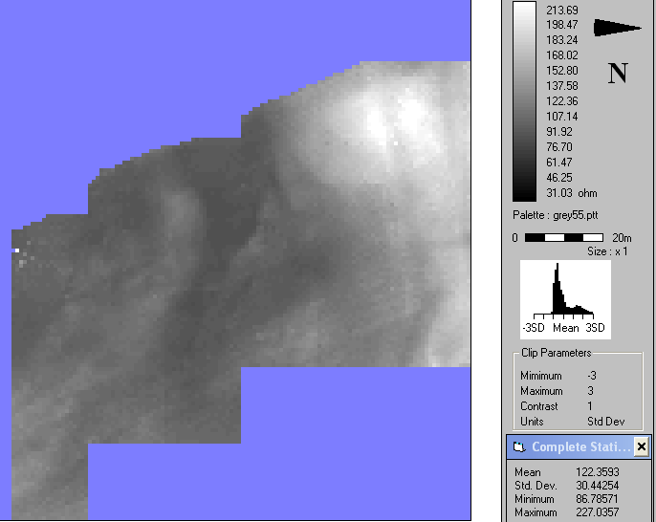

Figure 2 Butchers Field resistivity results: unprocessed data, 0.5m probe separation

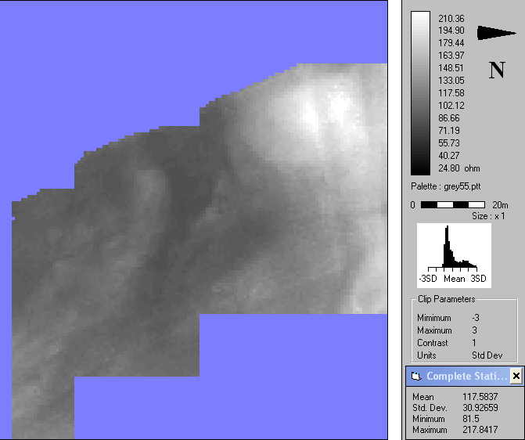

Figure 3 Butchers Field resistivity results: unprocessed data, 1.0m probe separation

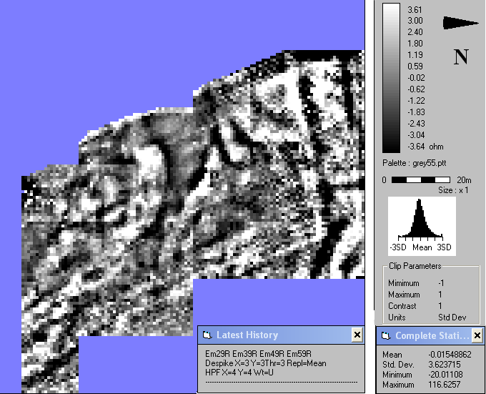

Figure 4a Butchers Field resistivity results: processed data, 0.5m probe separation, grey-scale plot
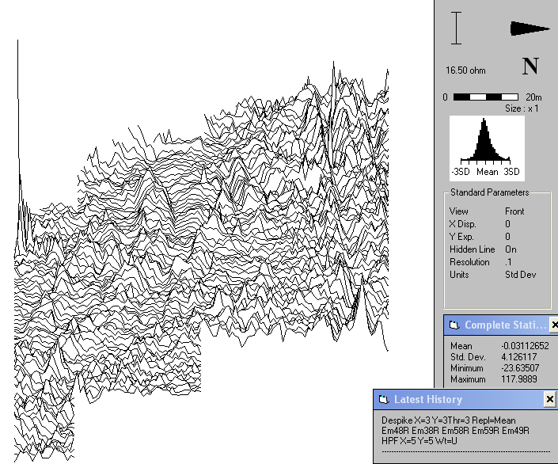

Figure 4b Butchers Field resistivity results: processed data, 0.5m probe separation, trace plot

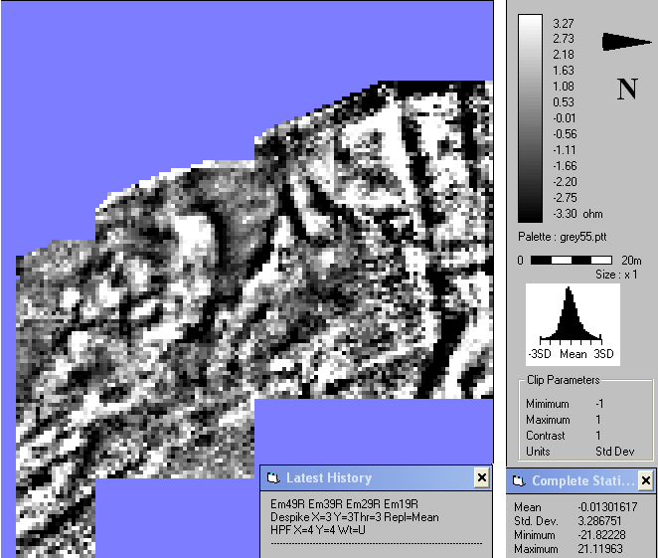

Figure 5a Butchers Field resistivity results: processed data, 1.0m probe separation, grey-scale plot

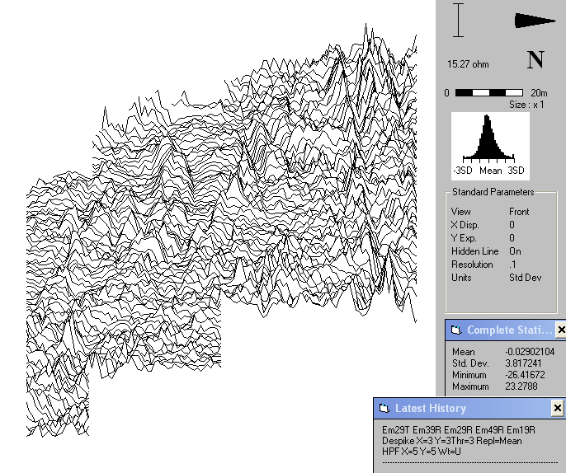

Figure 5b Butchers Field resistivity results: processed data, 1.0m probe separation, trace plot

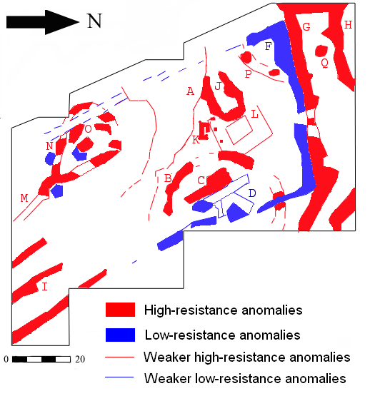
Figure 6 Butchers Field resistivity results: interpretative diagram

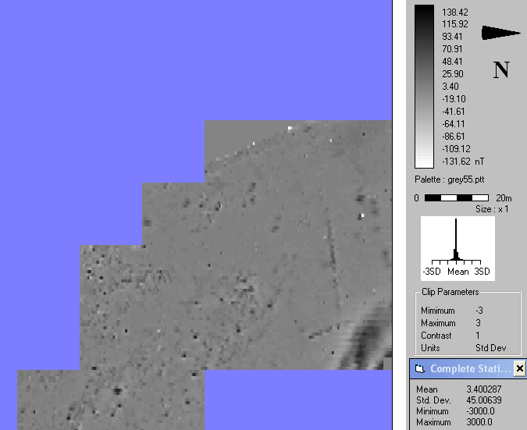

Figure 7 Butchers Field magnetometer results, unprocessed, grey-scale plot

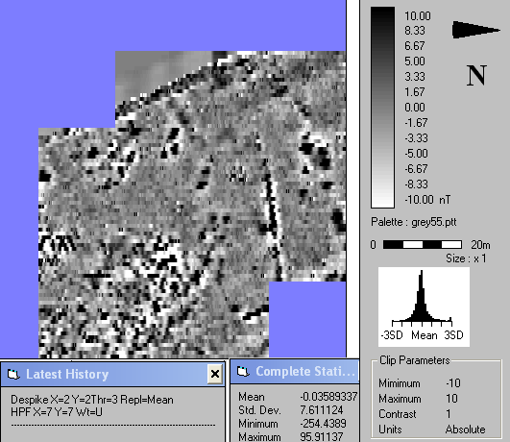

Figure 8 Butchers Field magnetometer results, processed, grey-scale plot

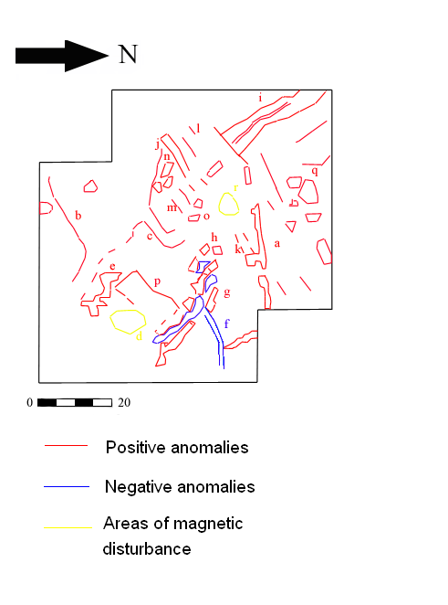

Figure 9 Butchers Field magnetometer results, processed, interpretative diagram

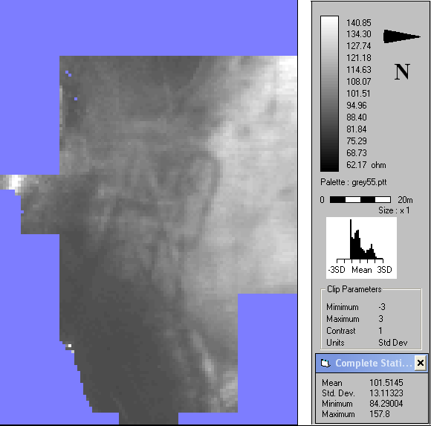

Figure 10 Glebe Field resistivity results: unprocessed data, 0.5m probe separation

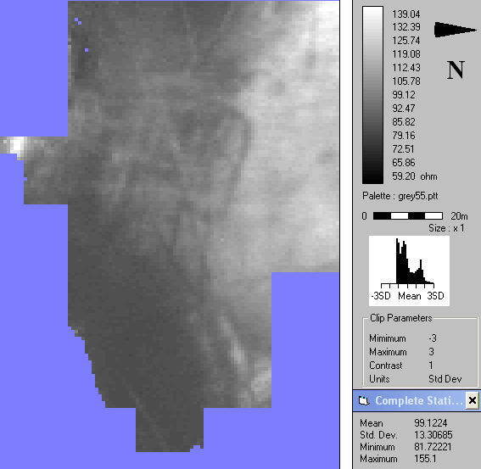

Figure 11 Glebe Field resistivity results: unprocessed data, 1.0m probe separation

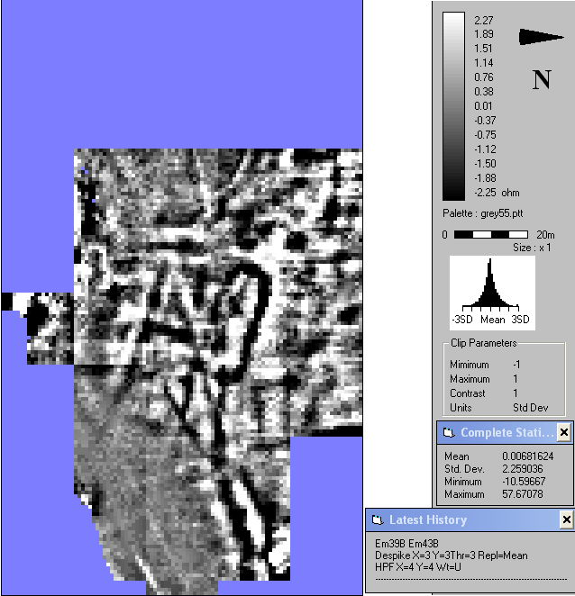

Figure 12a Glebe Field resistivity results: processed data, 0.5m probe separation, grey-scale plot

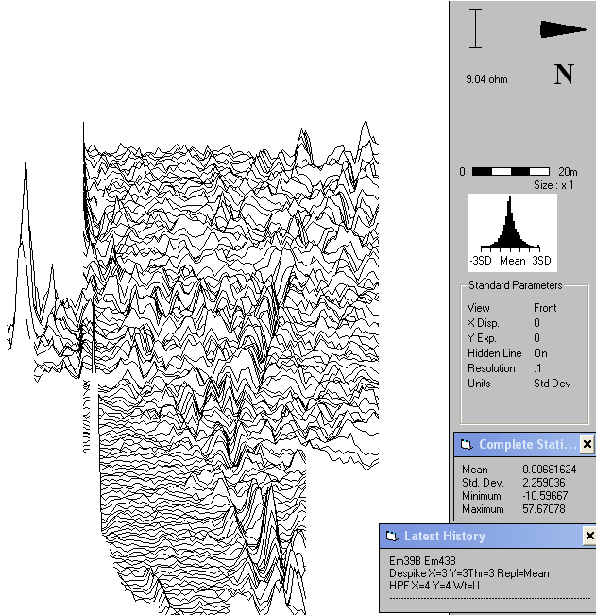

Figure 12b Glebe Field resistivity results: processed data, 0.5m probe separation, trace plot

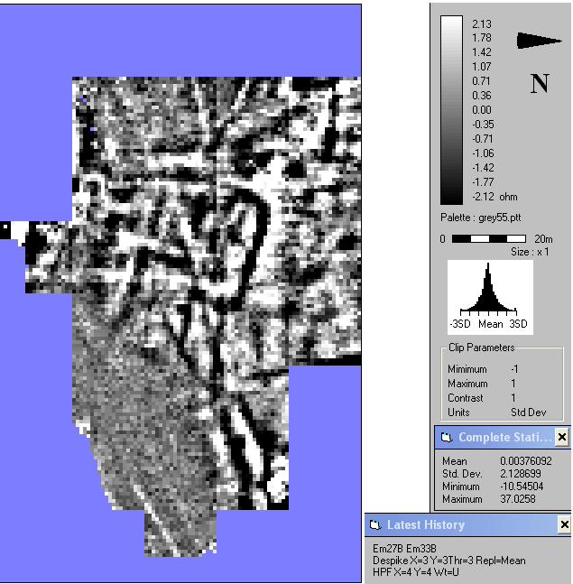

Figure 13a Glebe Field resistivity results: processed data, 1.0m probe separation

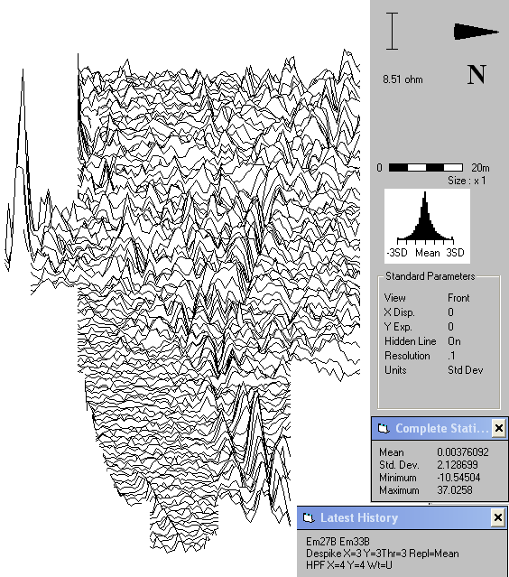

Figure 13b Glebe Field resistivity results: processed data, 1.0m probe separation, trace plot

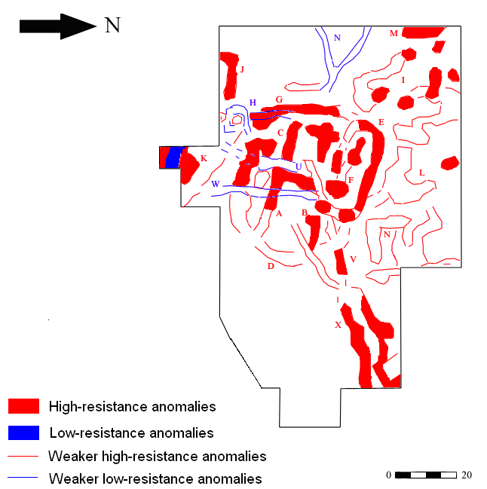

Figure 14 Glebe Field resistivity results: interpretative diagram

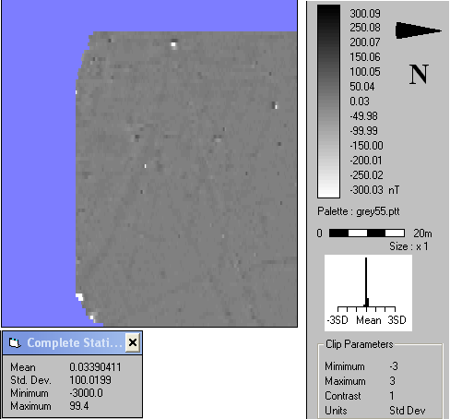

Figure 15 Glebe Field magnetometer results: unprocessed data, grey-scale plot

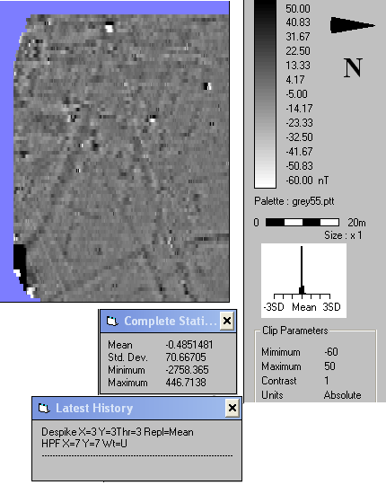

Figure 16a Glebe Field magnetometer results: processed data, grey-scale plot

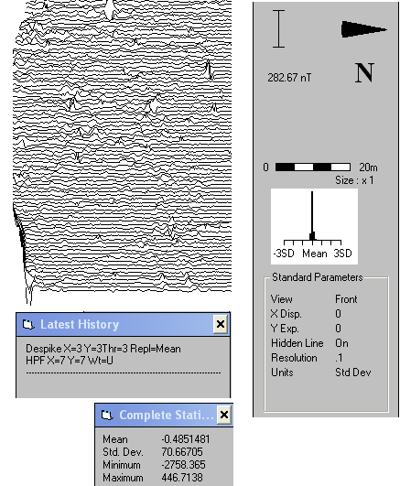

Figure 16b Glebe Field magnetometer results: processed data, trace plot

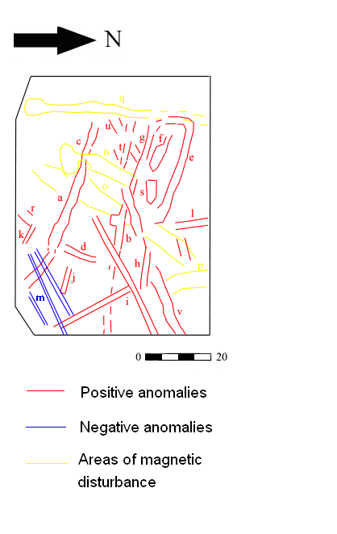
Figure 17 Glebe Field magnetometer results: interpretative diagram

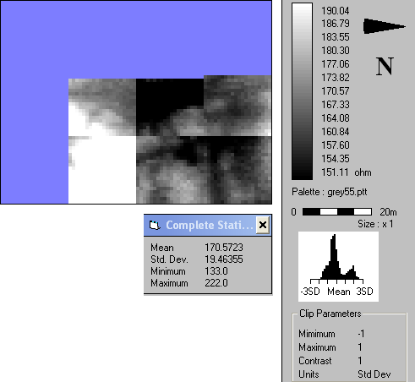
Figure 18 Glebe Field, survey area II, resistivity results: unprocessed data, 0.5m probe separation

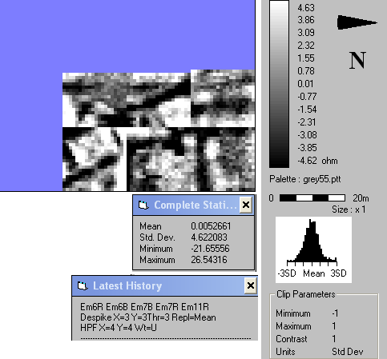

Figure 19 Glebe Field, survey area II, resistivity results: processed data, 0.5m probe separation

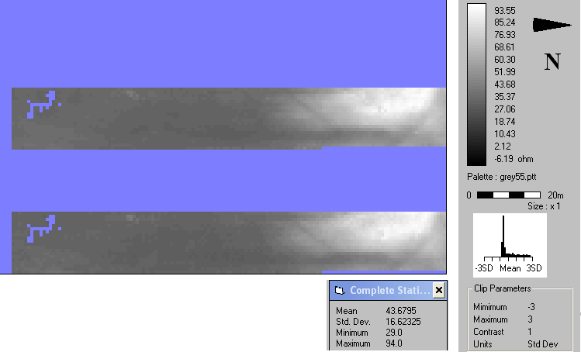

Figure 20 Kilspindie Golf Course, resistivity results: unprocessed data, 0.5m probe separation (top); 1.0m probe separation (bottom)

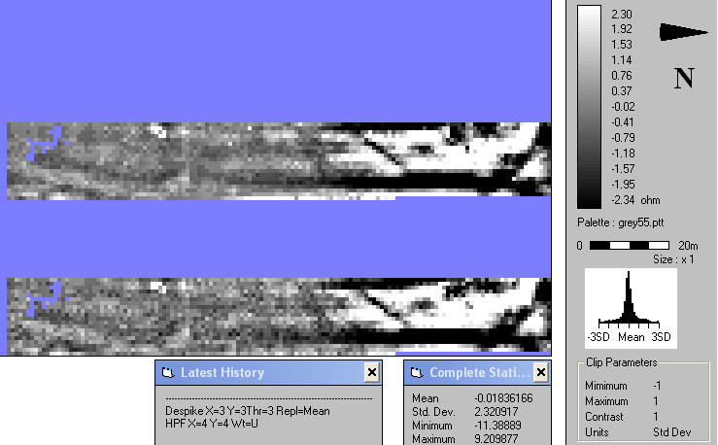

Figure 20 Kilspindie Golf Course, resistivity results: processed data, grey-scale plots, 0.5m probe separation (top); 1.0m probe separation (bottom)
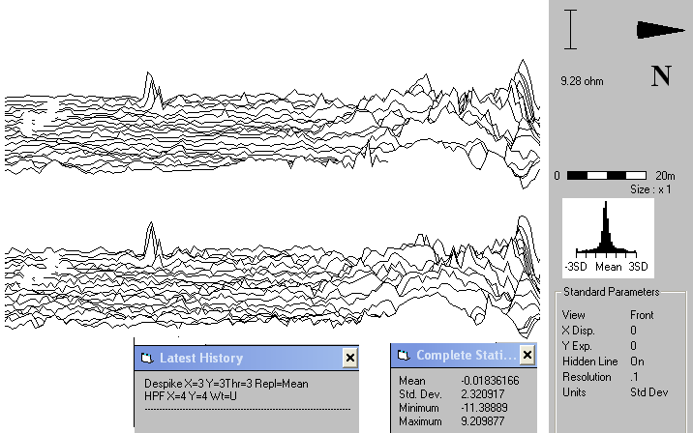

Figure 21 Kilspindie Golf Course, resistivity results: unprocessed data, trace plots, 0.5m probe separation (top); 1.0m probe separation (bottom)

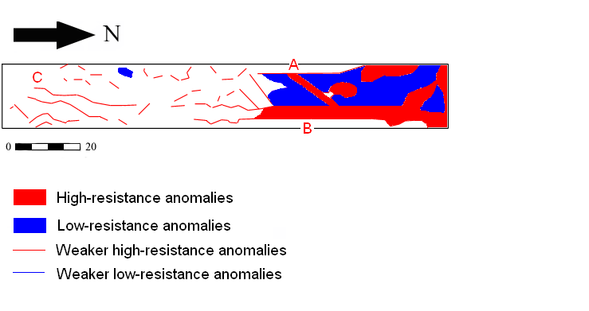
Figure 22 Kilspindie Golf Course, resistivity results: interpretative diagram

